Scientist: _____________________
Due Date: ______________

THE ORIGINS OF THE UNIVERSE
The BIG BANG!!!
The discovery of the Big Bang began with AT&T Phone Company. In 1960, Bell Labs built a giant antenna in Holmdel, New Jersey called Echo, which could send signals across long distances.
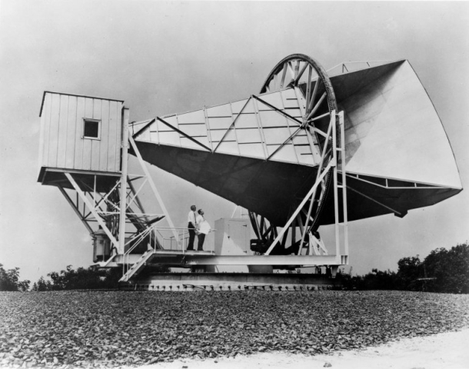
Within a few years, the Telstar satellite was launched. It had built-in transponders and made the Echo system obsolete. Meanwhile, two employees of Bell Labs had had their eye on the antenna.
Arno Penzias joined Bell Labs in 1958. He had done his PhD on using masers (microwave amplification by stimulated emission of radiation) to amplify and measure radio signals from the spaces between galaxies. He knew the Holmdel antenna would also make a great radio telescope and was hoping to use it to continue his observations.
Another radio astronomer came to Bell Labs in 1962 with the same idea. Robert Wilson had also used masers to amplify weak signals in mapping radio signals from the Milky Way. The launch of Telstar in 1962 gave both researchers what they wanted: the Holmdel antenna was freed up for pure research.

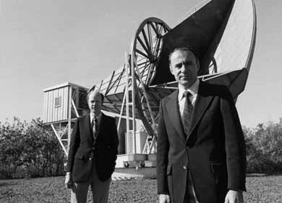

When they began to use it as a telescope, they found there was a background "noise" (like static in a radio) seeming to come from all directions. They determined that this noise was what was causing the annoying hissing sound in the telephone calls of the time and they measured it as a uniform signal in the microwave range.

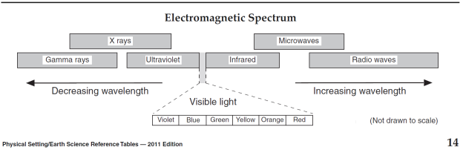
They checked everything they could think of to rule out the source of the excess radiation. They pointed the antenna right at New York City and when they determined it wasn't coming from urban interference, radiation within our galaxy, or extraterrestrial radio sources… Penzias and Wilson began looking for theoretical explanations.
Around the same time, Robert Dicke at nearby Princeton University had been pursuing theories about the big bang. He had elaborated on existing theory to suggest that if there had been a big bang, the residue of the explosion should by now take the form of a low-level background radiation throughout the universe.

Since Penzias, Wilson, and Dicke's discovery, the measurement of cosmic background radiation (as the “noise” is now called), combined with Edwin Hubble's observation that the galaxies in the universe are all rushing away from each other, makes a strong case for the big bang. Penzias and Wilson received the Nobel Prize in physics in 1978.

http://www.pbs.org/wgbh/aso/databank/entries/dp65co.html

Discussion Questions:

- Penzias and Wilson were both ___________ astronomers before they worked for Bell Labs, who worked specifically with ___________.

- “Echo” is a giant _____________, and Telstar is a _______________.

- The “noise” that Penzias and Wilson found using the radio antenna is a faint signal of _______________ radiation, is now believed to be leftover energy from the ___________________.

- Penzias and Wilson began looking for theoretical explanations for the source of the excess radiation…

  - because they wanted to win the Nobel Prize.
  - because as scientists, they liked making up theories.
  - because they had ruled out every possible source they could think of.

- The Big Bang Theory is widely accepted as the origin of the universe in todays scientific community, not only because of the cosmic background radiation, but also because of Edwins Hubble’s observation that ________________________________________________________________________________

